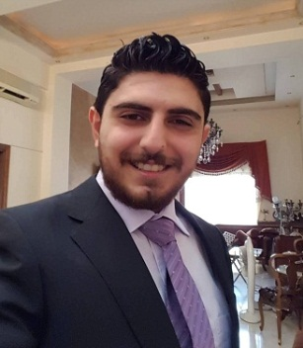**Address : Erbil – Iraq**

**Phone : +964 750 859 52 17**

**Email : firassa547@gmail.com**

**Nationality : Syrian**

**Marital Status : Single**

**DOB : 14 April 1993**

Education ;

**Bachelor's Degree** of **Electrical Engineering ( Computer and Automation ) - University of Damascus / 2018**

Experience ;

**1- Sales Manager :**

**Abbott Diagnostis Company - Syria**

2016 - 2018

Achieving growth and hitting sales targets by successfully managing the sales team, Designing and implementing a strategic sales plan that expands company’s customer base and ensure it’s strong presence, Managing recruiting, objectives setting, coaching and performance monitoring of sales representatives.

**2- Electrical Technician :**

**Abbott Diagnostis Company - Syria**

2015 – 2016

Assemble, install, test, and maintain laboratory instruments using hand tools and power tools, Inspect electrical systems, equipment, and components to identify hazards, defects, and the need for adjustment or repair, and to ensure compliance with codes, Advise management on whether continued operation of equipment could be hazardous.

**3- Electrical Technician :**

**Modern Furniture Rajha Mika - Syria**

2012 – 2014

**4- Distributor ( Volunteer for 3 months ) :**

**Syrian Red Crescent - Syria**

Facilitate and Coordinate activities within SRC and between Partners in project areas, participating in multidisciplinary teams and meetings regarding, for example, distributing goods , To ensure adequate reporting and documentation of all FSL related Activities

**5 - Salesman ( Self Employed ) :**

**Sameer for Fabrics - Syria**

2009 – 2012

Welcoming customers by greeting them; offering them assistance, Directing customers by escorting them to racks and counters; suggesting items, Advising customers by providing information on products .

**Language Skills;**

* Arabic ( Native ) Mother Language
* English Very Good
* French Good

**Training Courses and Certificates ;**

* **Computer Training Course ( CCNA )** for three months at **New Horizon – Syria - Damascus / 2018**
* **Data Base SQL Training for** three months at **New Horizon – Syria - Damascus / 2016**

**Computer Skills;**

* Microsoft Office
* Laboratory Computer Systems
* Internet ( Browsing , Email and Social Media )

**Other Skills ;**

* Driving License
* Interpersonal and communication skills
* Team work
* Good time management
* Maintenance of confidentiality
* Confident, Friendly and Approachable
* Ability to work under pressure
* Loyalty, Positivity, Creativity and Adaptability

**Target Job ;**

**Career Objective :** To build careers in a growing organization, where I can get the opportunities to prove my abilities by accepting challenges fulfilling organizational goal and climbing the career loader through continuous learning and commitment .

**References :**  Available upon Request